- Create 3 mandatory roles FullRights, Administrator, InteractiveOpenExtReportsAndDataProcessors, include them in the main roles of the configuration. Create a user Administrator, assign all 3 of these roles to him.
Tip: to speed up the process of assigning rights, I recommend starting to assign rights from the end to the beginning, i.e. If you want to grant the rights "Read", "View" and "String input", then you can simply grant the right "String input", the rights "Read" and "View" will be automatically enabled.
- Rename the configuration (change the configuration root Name property) to something more suitable for your software solution.
- Create the roles CEO, PurchaseManager, SalesManager, Storekeeper, MasterDataSpecialist, which allow working with one or more subsystems, based on the role names. The CEO role must have the same rights to work with objects as the FullAccess role, except for the "Totals control" right for registers, but must not have administrative rights to the configuration root, for example, "Administration" (though it is quite possible to grant the "Advanced tools" right so that the user with this role can use the "Functions for technician…" command in the main menu. The role of MasterDataSpecialist gives the right to create and change all reference information: Products, Companies, Warehouses, etc. Other roles should have the right to change master data by meaning, for example, the Purchase manager should be able to create new product items, since he can enter a document reflecting the purchase of new goods. The Sales manager should be able to enter new counterparties and counterparty contracts…
Tip: for roles that will have similar read/view rights, and the main differences will be in the rights to insert/update/other, I recommend creating a role, assigning rights that will be found in other roles, then creating other roles by copying this one and then changing each role as needed.
- All users should be able to create new characteristics (the "Additional attributes and properties" chart of characteristic types) and additional characteristic values (the "ObjectsPropertiesValues" catalog). None of these roles, except for the CEO role, should have the right to delete objects. Only the roles of CEO and FullAccess should have the right to edit constants.
- No role should give the right to interactively delete objects and rights associated with the deletion of predefined objects (information was in the theoretical part of the lesson).
- Do not grant rights to update and edit accumulation registers, instead use the privileged mode of posting and undo posting documents. Usually it is enabled by default, but if it is not, enable it at the "Rights" tab of a document.
- Create at least one user for each "job" role (point 3 of this task) and test the application on behalf of each user. Do not forget about reports and data processors, which also need to be tested. If some rights are missing that the user should have according to their role, modify the roles so that the user has enough rights or use the privileged mode to obtain data.
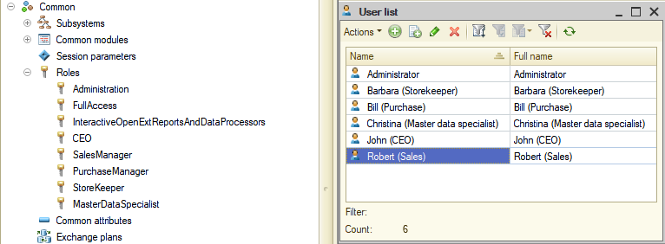

As a result of my tests, I found that the "Fill by sales document" button in the "Return of goods from customer" document is available even when other elements are unavailable (when a user does not have rights to edit the object).
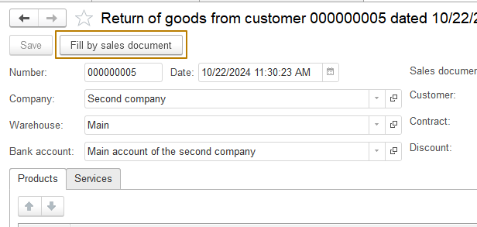
This happened because I forgot to enable the "Modifies saved data" flag for the command. It is enough to enable this flag and the platform will control the availability of the button depending on the user's rights:
